**1. ReactJS-HOL**

**CODE:**

App.js

function App() {

  return (

    <div>

      <h1>Welcome to the first session of React</h1>

    </div>

  );

}

export default App;

**OUTPUT:**

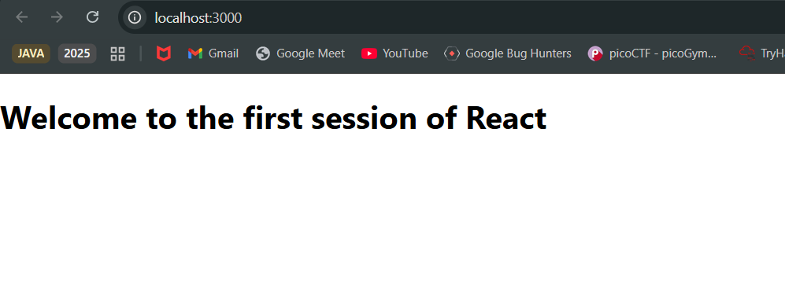

**2. ReactJS-HOL**

**CODE:**

Home.js

import React from 'react';

function Home() {

  return (

    <div>

      <h2>Welcome to the Home page of Student Management Portal</h2>

    </div>

  );

}

export default Home;

**About.js**

import React from 'react';

function About() {

  return (

    <div>

      <h2>Welcome to the About page of the Student Management Portal</h2>

    </div>

  );

}

export default About;

**Contact.js**

import React from 'react';

function Contact() {

  return (

    <div>

      <h2>Welcome to the Contact page of the Student Management Portal</h2>

    </div>

  );

}

export default Contact;

**App.js**

import React from 'react';

import Home from './Components/Home';

import About from './Components/About';

import Contact from './Components/Contact';

function App() {

  return (

    <div className="App">

      <Home />

      <About />

      <Contact />

    </div>

  );

}

export default App;

**OUTPUT:**

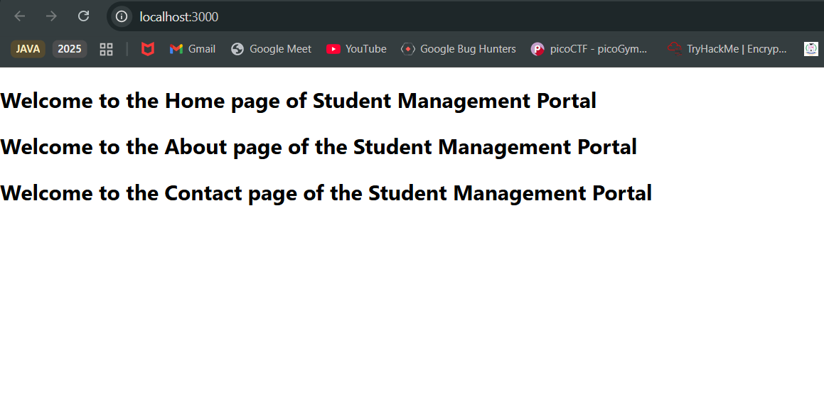

**3. ReactJS-HOL**

**CODE:**

CalculateScore.js

import React from 'react';

import '../Stylesheets/mystyle.css';

function CalculateScore() {

  const name = "John Doe";

  const school = "Green Valley High";

  const total = 450;

  const goal = 5;

  const average = total / goal;

  return (

    <div className="score-container">

      <h2 className="title">Student Score Report</h2>

      <p className="info">Name: {name}</p>

      <p className="info">School: {school}</p>

      <p className="info">Total Marks: {total}</p>

      <p className="info">Subjects: {goal}</p>

      <p className="average">Average Score: {average}</p>

    </div>

  );

}

export default CalculateScore;

**App.js**

import React from 'react';

import CalculateScore from './Components/CalculateScore';

function App() {

  return (

    <div className="App">

      <CalculateScore />

    </div>

  );

}

export default App;

**OUTPUT:**

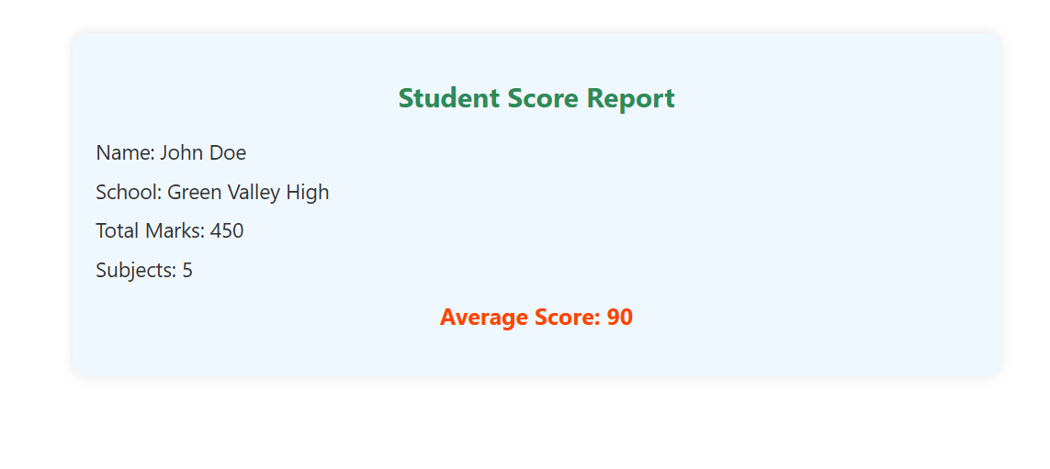

**4. ReactJS-HOL**

**CODE:**

Posts.js

import React from 'react';

import Post from './Post';

class Posts extends React.Component {

  constructor(props) {

    super(props);

    this.state = {

      posts: [

        { id: 1, title: "Welcome to React", body: "React makes it easy to build UIs with components." },

        { id: 2, title: "Class vs Function Components", body: "Both are useful; function components use hooks!" },

        { id: 3, title: "Why Learn React?", body: "React is one of the most popular frontend libraries." }

      ],

      error: null

    };

  }

  componentDidCatch(error, info) {

    alert("Error occurred: " + error.toString());

  }

  render() {

    return (

      <div>

        <h2>Blog Posts</h2>

        {this.state.posts.map((post) => (

          <Post key={post.id} title={post.title} body={post.body} />

        ))}

      </div>

    );

  }

}

export default Posts;

**App.js**

import React from 'react';

import Posts from './Posts';

function App() {

  return (

    <div className="App">

      <Posts />

    </div>

  );

}

export default App;

**OUTPUT:**

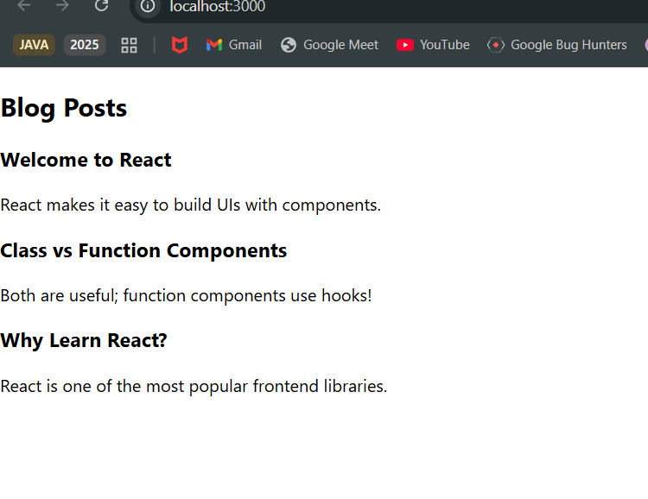

**5. ReactJS-HOL**

**CODE:**

App.js

import React from 'react';

import CohortDetails from './CohortDetails';

function App() {

  const cohorts = [

    {

      name: "INTADMDF10 -.NET FSD",

      startDate: "22-Feb-2022",

      status: "Scheduled",

      coach: "Ashok",

      trainer: "Jose"

    },

    {

      name: "ADM21JF014 - Java FSD",

      startDate: "10-Sep-2021",

      status: "Ongoing",

      coach: "Kamal",

      trainer: "Mukesh"

    },

    {

      name: "CDBJF21025 - Java FSD",

      startDate: "24-Dec-2021",

      status: "Ongoing",

      coach: "Raj",

      trainer: "Jaya"

    }

  ];

  return (

    <div style={{ padding: "20px" }}>

      <h2>Cohorts Details</h2>

      {cohorts.map((cohort, index) => (

        <CohortDetails key={index} {...cohort} />

      ))}

    </div>

  );

}

export default App;

**OUTPUT:**

